**WEEK-2**

**Logging using SLF4J**

**Exercise 1: Logging Error Messages and Warning Levels**

**CODE:**

**Step1:**

Added SLF4J + Logback Dependencies to pom.xml

**Step2:**

Create the Logging Java Class (LoggingExample.java)

Located in com.example.JUnitDemo in src/main/java

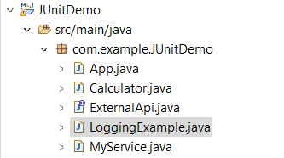

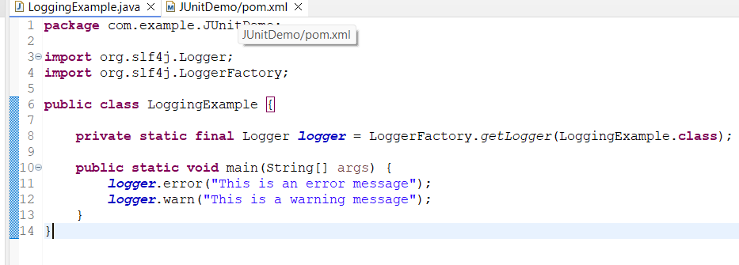

**OUTPUT:**

